PRIMER ON TEG (Thromelastography)

Background: TEG is a whole-blood assessment of clotting ability. Whereas PT/PTT/INR use serum to assay for clotting factor activity, TEG takes into account the contribution of the platelet and RBC. Furthermore, TEG allows us to assess clot stability and measures the percentage of formed clot that ultimately lysis leading to ongoing or recurrent bleeding.
The test is performed by placing a specimen of whole blood into a cup. The a pin suspended into the cup which then rotates at a fixed rate to allow mixing of coagulation factors, platelets, and red blood cells. This causes clot to form. As the clot forms, the pin starts to rotate as well and a graph is generated (see figures 1a-c).
Different types of TEG assays:
- Standard (Koalin) TEG: This assays allows measurement (mostly) of the instrinsic and common pathways (see figure 2). The “R” value corresponds to factor activity. Thus a prolonged R value should be treated, in most cases, with FFP transfusion. The R value should be expected to be prolonged with heparin and probably with oral anticoagulant agents that affect factor X or II. It may also be prolonged in hypofibrinogemic states. The alpha angle corresponds to the thrombin burst and conversion of fibrinogen to fibrin. A low alpha angle should be treated in most cases with cryoprecipitate. The MA (maximal amplitude) corresponds to overall clot strength. In most cases, 80% of the MA is made up by platelet function and 20% is made up by fibrin. The MA represents the maximal clot strength available using pharmacologic doses of thrombin and may not represent the actual clot strength in the patient in vivo. A low MA can be treated with either a platelet transfusion (most cases) or cryoprecipitate to increase the fibrinogen level or both. The LY30 is the percentage of clot that lyses in 30 minutes. Although the upper limit is 8%, some studies suggest that any number greater than 3% is associated with significant hemorrhage in trauma patients. Patients with an elevated LY30 can be treated with tranexamic acid (TXA) or Amicar.
- Rapid TEG: This assay uses tissue factor as a catalyst. Therefore, it mostly assays the extrinsic pathway and the common pathway (see figure 2). The lab will not report alpha angle, MA, or LY30 if a rapid TEG is ordered. To get those variables, you have to order a standard TEG in addition to rapid TEG.
- Heparinase TEG: This assay is a combination of a standard TEG and a TEG that is run with heparinase added to the specimen. It determines if a patient is coagulopathic due to the presence of heparin. The R value of the specimen is compared to the R value of the specimen plus heparinase. If there is a difference in the R values, the patient is coagulopathic due to heparin and can be treated with protamine. In addition to the R value, a heparinase TEG will give alpha angle, MA, and LY30.
- Platelet Map TEG: The purpose of this test is to determine the degree to which patients who are on ASA or Plavix (clopidogrel) have inhibited platelet function. However, there are no normal values for degree of inhibition and there are no values which define propensity for bleeding. Therefore, we cannot recommend a threshold for transfusion of platelets using this test currently. If you order this test and need help interpreting it, please contact Dr. Sarani or Dr. DePalma (Pathology).
Viewing the TEG tracing:
- Cerner will report the TEG values only when the TEG assay has been fully completed.
- You can view the tracing in real-time by entering the physician portal and then clicking on the TEG icon. Drop the userid field down and click on “site administrator”. The password is TEG.

Figure 1a: Labelled TEG Tracing
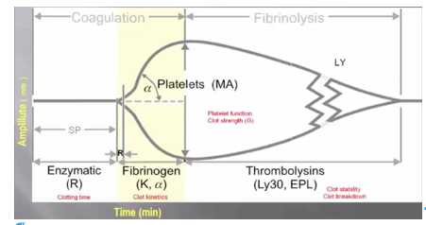
Figure 1b: Standard TEG Tracing
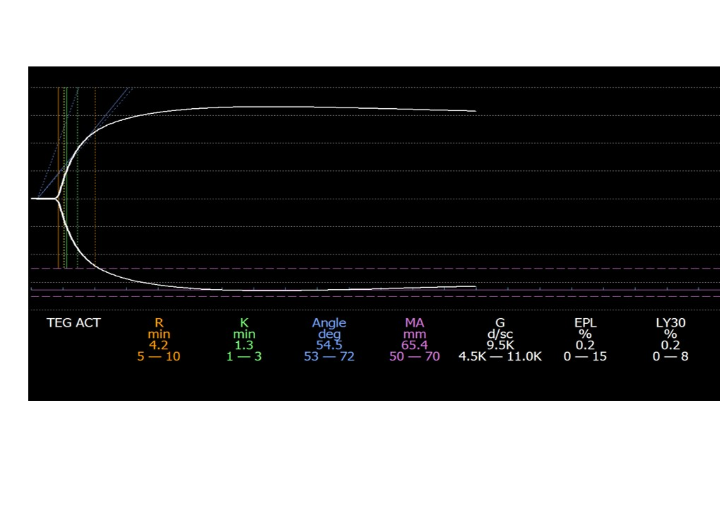
Figure 1c: Clot Lysis and diffuse coagulopathy
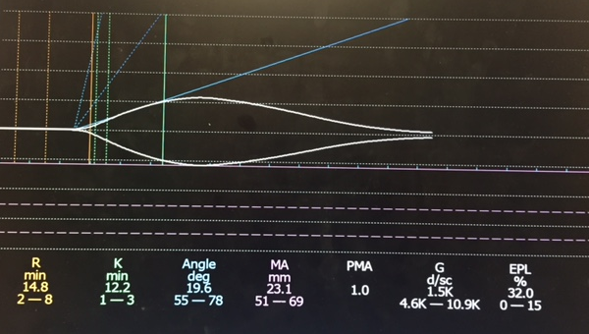
This tracing shows a prolonged R value (Needs FFP), low alpha angle (needs cryoppt), and low MA (needs Plts). In addition, the pt is in DIC with a near 100% lysis of clot (needs TXA).

Figure 2: The Coagulation Cascade
